The following is a dump of a TCP header in hexadecimal format 053200217 000000001 00000000 500207FF 00000000
- 1) What is the source port number?
- 2) What is the destination port number?
- 3) What is sequence number?
- 4) What is the acknowledgement number?
- 5) What is the length of the header?
- 6) What is the type of the segment?
- 7) What is the window size
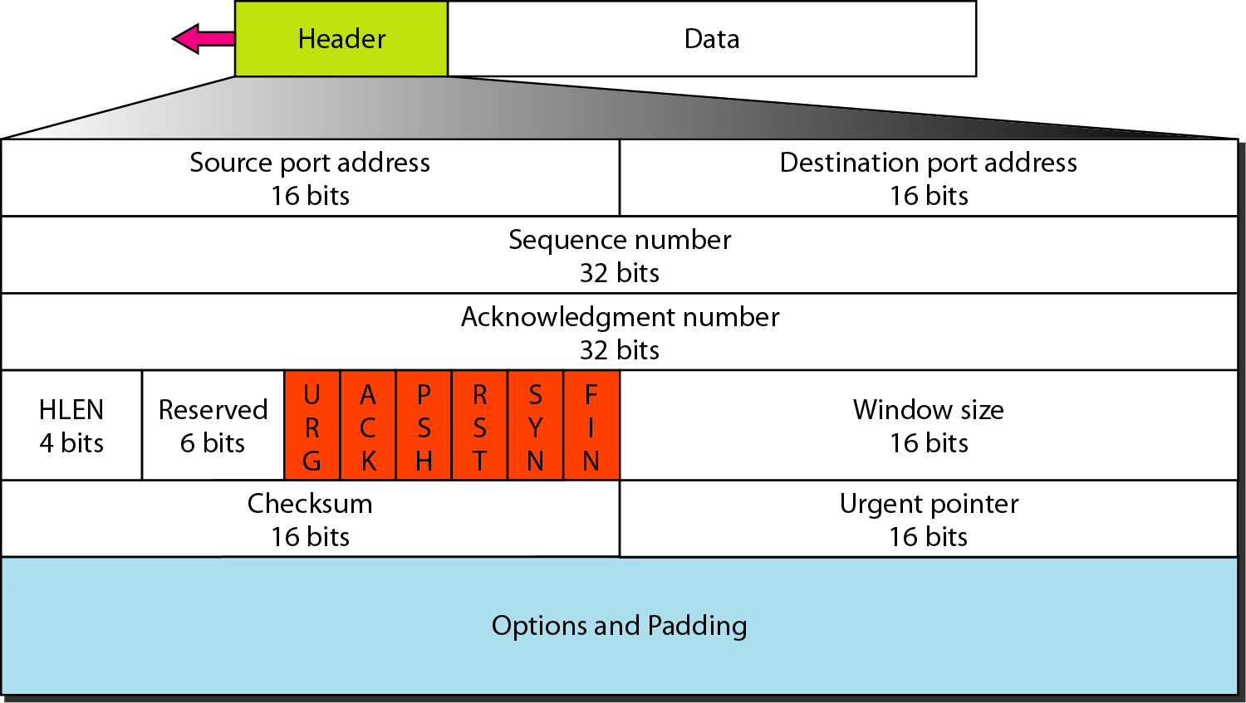

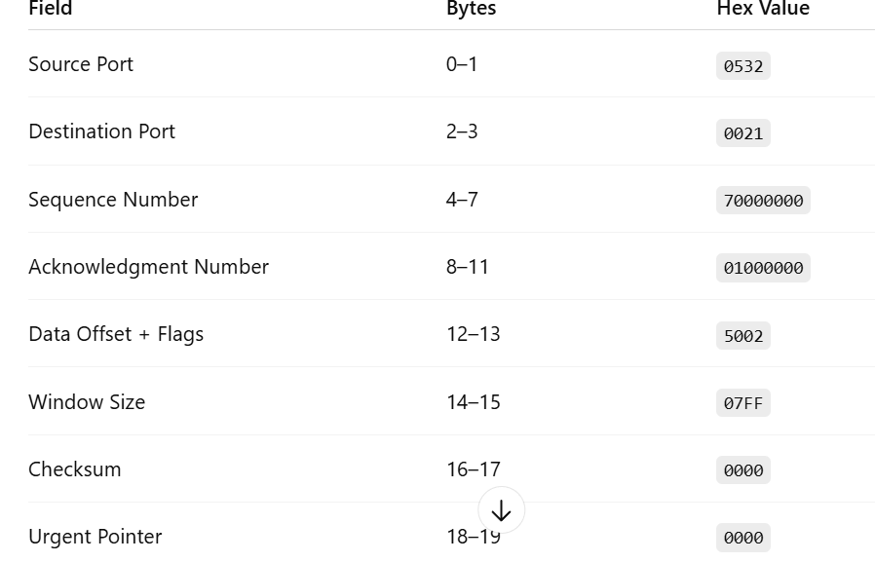
Solution

- Source Port Number
Hex: 0532 Convert to decimal: 0x0532 = 1330
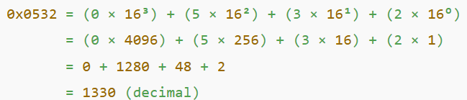
- Destination Port Number

Hex: 0021 Decimal: 0x0021 = 33

3) Sequence Number

Hex: 70000000 Decimal: 0x70000000 = 879048192

4) Acknowledgement Number
Hex: 10000000 Decimal:0x10000000 = 268435456

5) Header Length
Hex: The first nibble (4 bits) of 5002 indicates the header length.
- 5 in hex = 5 * 4 = 20 bytes

6) Type of the Segment (Flags)

5002 07FF 0000 0000
From 5002:
- The lower 12 bits are flags: 0x002
- This means only the SYN flag is set.

Explanation
This 16-bit field consists of:

- First 4 bits → Header Length

- Next 3 bits → Reserved bits (usually 0)

- Last 9 bits → Control Flags

Hex Value: 5002
Convert to binary (16 bits):
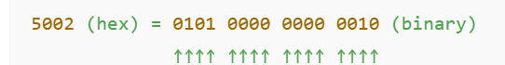
Split into:
- 0101 → Header Length = 5 × 4 = 20 bytes
- 000 → Reserved bits
- 000000010 → Control Flags
Answer: SYN

7) Window Size
Hex: 07FF Decimal:0x07FF = 2047

- a) The following is a dump of a UDP header in hexadecimal format. 0632 000D OO lC E217
a. What is the source port number?
b. What is the destination port number?
c. What is the total length of the user datagram?
d. What is the length of the data?
Solution
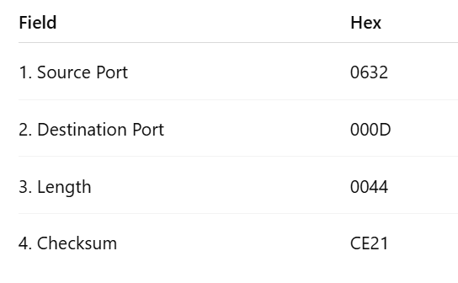

What is the source port number?
- Hex: 0632 Convert to decimal: 0x0632 = 1586

b. What is the destination port number?
- Hex: 000D Decimal: 0x000D = 13

c. What is the total length of the user datagram?
- Hex: 0044
- Decimal: 0x0044 = 68 bytes
This includes UDP header (8 bytes) + data (payload).

d. What is the length of the data?
- Total length = 68 bytes
- UDP header = 8 bytes
Data length = 68 − 8 = 60 bytes

